Title: Global presence of McDonald's

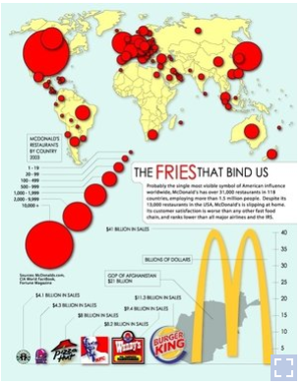

Briefly describe the context for the visual by addressing the following questions:

1. What is the source of the visual? (e.g., URL or bibliographic citation)
2. Who is the intended audience (i.e., decoders)? How do you know this?

his article showcases the chart I want to discuss: [https://www.npr.org/sections/thesalt/2013/07/25/205547517/where-in-the-world-are-there-no-mcdonalds?...](https://www.npr.org/sections/thesalt/2013/07/25/205547517/where-in-the-world-are-there-no-mcdonalds?..).  
  
Princeton University's International Networks created this map to showcase the global presence of McDonald's.   
Especially this chart tries to justify what Miguel Centeno, a sociologist at Princeton University, says: "If you want a definition of what the rich world and the poor world are, well, if you can get a McDonald's, you are in the rich world". Then he adds: "If you look at where these restaurants are located, it doesn't map on to culture; it maps on to money."  
So this map tries to be an infographic which wants to inform people about the global presence of Mc Donald's restaurants all over the world; also (the part below) tries to link this information to the wealth of the different countries.  
The **intended audience** is everyone who wants to increase his knowledge about the relationship between the numbers of Mc Donald's restaurants in a specific country and how rich is that country.  
**How do we know that**: The label on the right, titled "The fries that bind us", is a brief explanation of the question which the map intends to analyze, and it is clearly addressed to a large audience: for instance, there are no scientific words, the language used is simple and plain.

1. Identify the specific component(s) of the visual that is/are misleading
2. For each part(s) of the visualization that is/are misleading, identify the mechanism that is used: hiding relevant data to highlight what benefits us; displaying too much data to obscure reality; using graphic forms in inappropriate ways (distorting the data)
3. Explain how the mechanisms are used to mislead

I want to underline one element in this data representation: the more Mc Donald's restaurants are in a specific country, the bigger is the red circle in that country.  
The problem concerned with this data visualization is essential the following: **using graphic forms in inappropriate ways (distorting the data)**.   
**How the mechanism is used to mislead**: the size of the different categories is arbitrary, so the smallest circle contains from 1 to 19 restaurants, while in the second to last one falls the countries which own from 2000 to 9999 restaurants. In this chart, those 2 kinds of circles are compared, but you have not to take the difference between the sizes and associate it with the meanings of different circles.   
In other words, this representation is misleading because despite circles dimensions surely follow an order, information displayed is not precise and the scaling factor of the circles lead the readers astray.  
Once I have explained how the mechanism is used to mislead, let me clarify that by asking this question: Are there more Mc Donald's restaurants in North America or in Europe?   
From this map, it is impossible to answer.

SECOND:

Title: T**he Times Leaves the Rest Behind**

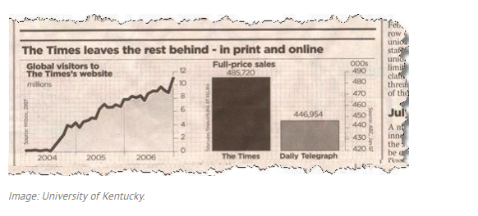

Briefly describe the context for the visual by addressing the following questions:

1. What is the source of the visual? (e.g., URL or bibliographic citation)
2. Who is the intended audience (i.e., decoders)? How do you know this?

<https://www.statisticshowto.datasciencecentral.com/misleading-graphs/>  
  
The intended audience is the reader of the The Times newspaper, as well as, advertisers who read the paper and make decisions on how much advertising to allocate to each newspaper.

1. Identify the specific component(s) of the visual that is/are misleading
2. For each part(s) of the visualization that is/are misleading, identify the mechanism that is used: hiding relevant data to highlight what benefits us; displaying too much data to obscure reality; using graphic forms in inappropriate ways (distorting the data)
3. Explain how the mechanisms are used to mislead

The chart on the left, only shows the global visitors to the The Times online site, but does not provide a comparison to that of the competitor (e.g. The Daily Telegraph, which is prominently shown in the graph next to it.  
Mechanism: Hiding relevant data  
  
The graph on the right has a highly truncated Y-axis that visually exagerates the difference between the newspaper.  The actual difference is less than 10%, but the Y-axis is 'zoomed in' to make it appear larger. The numbers speak for themselve, but the decoder would need to do some mental math to understand the distortion.  
Mechanish: Using graphic forms to distort data

Third

Title: **Distorting data through visual forms**

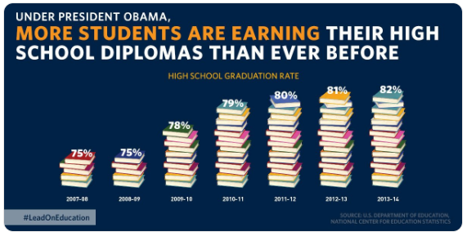

Briefly describe the context for the visual by addressing the following questions:

1. What is the source of the visual? (e.g., URL or bibliographic citation)
2. Who is the intended audience (i.e., decoders)? How do you know this?

Source of the visual:<https://twitter.com/obamawhitehouse/status/677189256834609152?lang=en>  
The intended audience is the public as it was a social tweet on Twitter.

1. Identify the specific component(s) of the visual that is/are misleading
2. For each part(s) of the visualization that is/are misleading, identify the mechanism that is used: hiding relevant data to highlight what benefits us; displaying too much data to obscure reality; using graphic forms in inappropriate ways (distorting the data)
3. Explain how the mechanisms are used to mislead

They truncated the Y-axis and used the no of books visual in order to distort the difference in the data shown.  
eg: They used 5 books to represent 75% and 10 books for 78% but for 79% they used 14 books so it would mislead the decoder into thinking that there is a large difference.  
**This is an example of using graphic forms in inappropriate ways (distorting the data).**